**Cairo University Faculty of Engineering**

**Advanced Topics in Electronics-1**

**Under supervision of:**

**Dr. Mohamed Youssef**

**Eng. Ahmed Atef**

**Students Names:**

**Kerolos Hanna Fayez 1200049**

**Omar Mohamed Said 1200859**

* **Show the block diagram of your proposed receiver**

All the indicated values are referenced from ADI website , TI website , lecture and Papers.

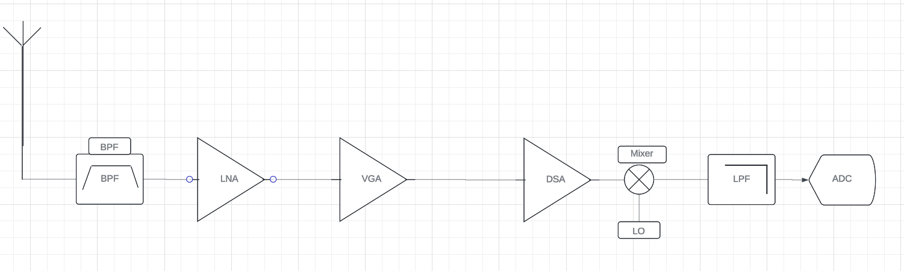the block proposed consists of BPF , LNA , VGA ,DSA, mixer, LPF

I also used amp/attenuator topologies as the NF needed to achieve the needed SNR at sensitivity was very low and the ${OIP}_{3}$ needed was achieved without attenuator/amp topologies.

it has multiple disadvantages like $LO$ leakage and dc offset.

The $BPF$ (passive) is used at the beginning to filter out of band blockers, and it was used in front of the LNA so the out of band blockers won’t reach the $LNA$ and cause desensitization to the signal and cause the gain to drop to zero, but it has a disadvantage that it causes the $NF$ to drop because of the loss that is add up across the chain.

A $VGA$ is used to achieve a gain up to $50 dB$ to have $P_{out}=-20 dBm$ at $P_{in}=-70 dBm$ programmable from $5dB$ to $37 dB$ with a step $1 dB$.

A $DSA$ is used to attenuate the Gain in case of gain needed $= 0 dB→5 dB$ for 🡺 programmable with a gain step of $2 dB$ with a range $(0 dB-46 dB)$ with $LPF$ (active filter) to filter the in-channel blockers.

* **Indicate all gain/noise/linearity specs for the receiver blocks**

The gain/noise/linearity specs for $P_{in}=-102 dBm$ spec for sensitivity, notice that $NF=2 dB$ which is required for a $SNR$ of $0 dB$. (We used $VVA$ as we did not find a $DSA$ on Qorvo)

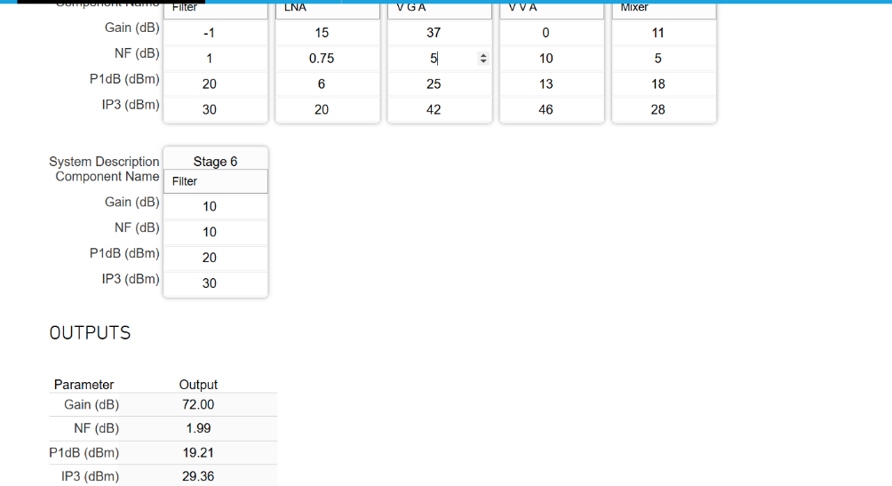

The gain/noise/linearity specs for $P_{in}=-70 dBm$

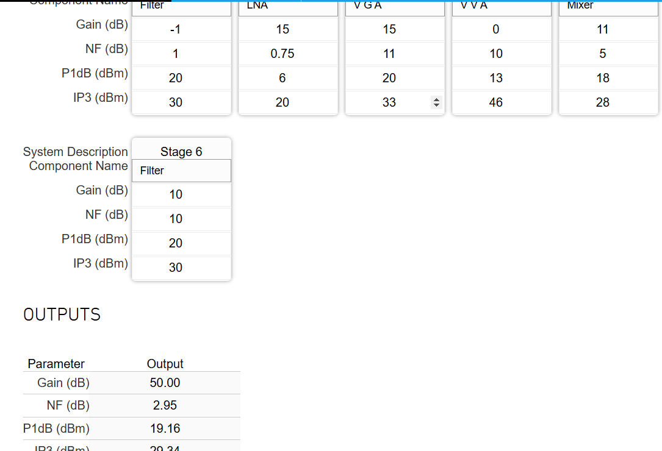

The gain/noise/linearity specs for $P_{in}=-60 dBm$

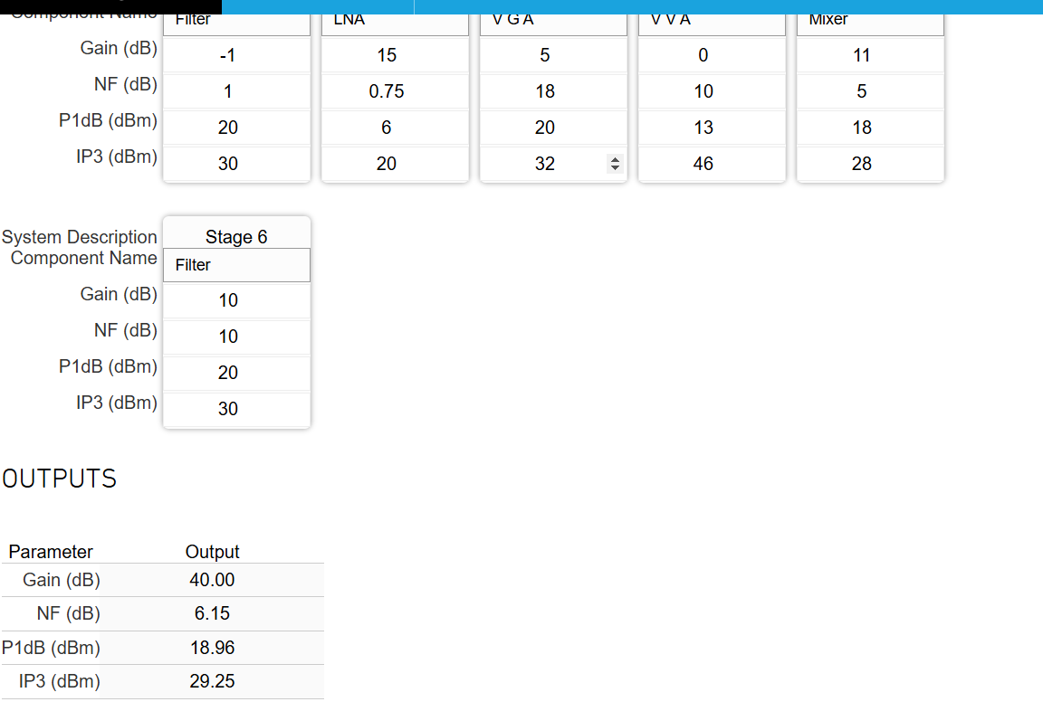

The gain/noise/linearity specs for $P_{in}=-50 dBm$

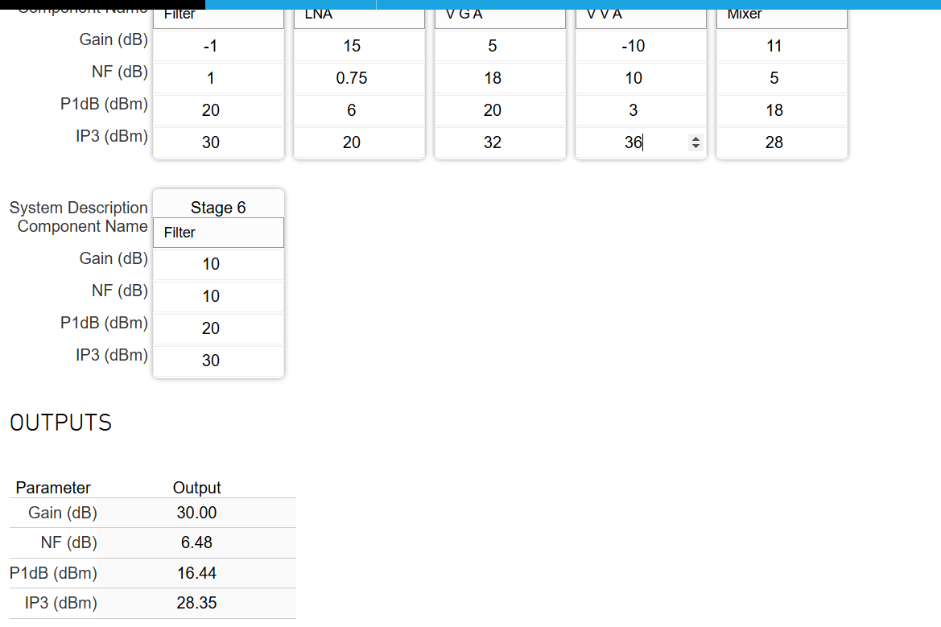

The gain/noise/linearity specs for $P_{in}=-40 dBm$

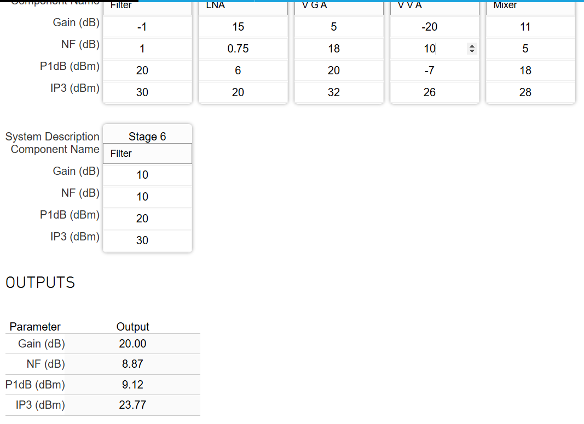

The gain/noise/linearity specs for $P_{in}=-30 dBm$

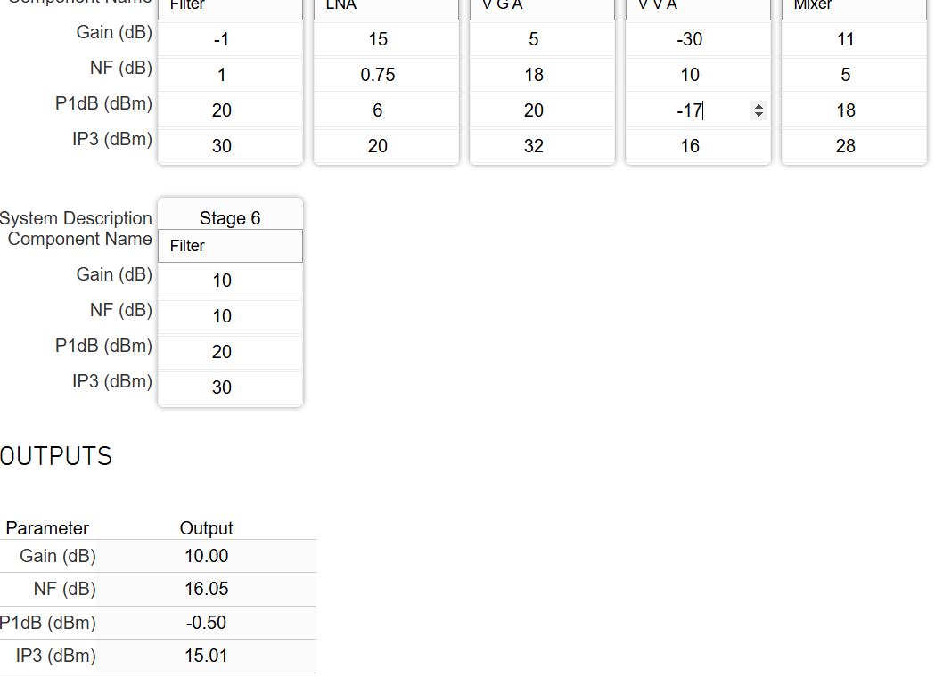

The gain/noise/linearity specs for $P_{in}=-20 dBm$

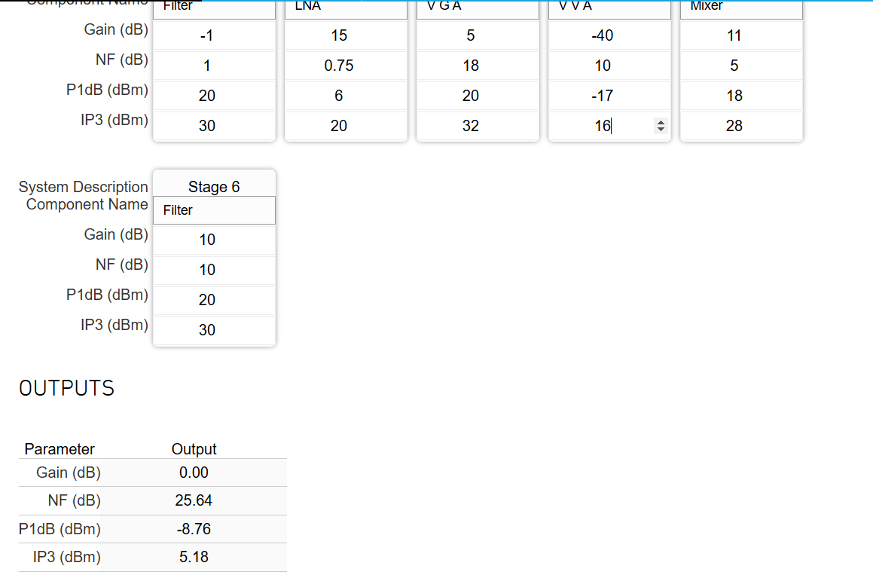

* **Provide $NF$ and ${IIP}_{3}$ plots versus gain**

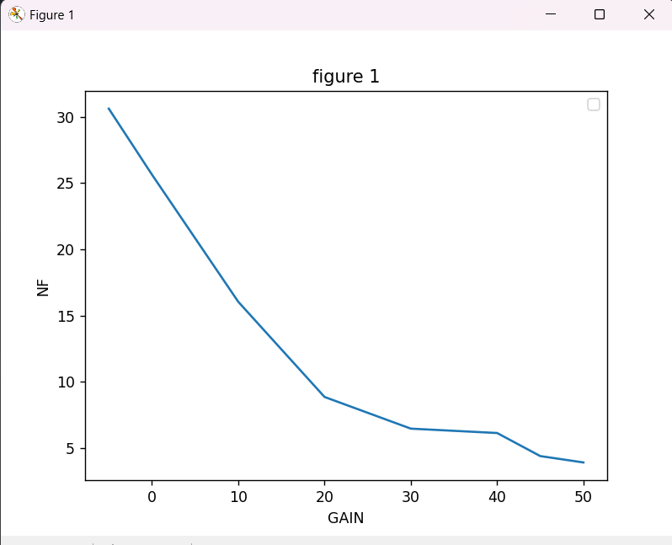

The noise figure began to saturate as the gain become higher because noise figure law (Frizz’s law) $={NF}_{1}+\frac{{NF}_{2}}{{AP}_{1}}+…+\frac{{NF}_{n}}{{AP}_{1}….{AP}_{n}-1}$ as gain increase noise figure decrease and it reaches a certain point and begin to saturate.

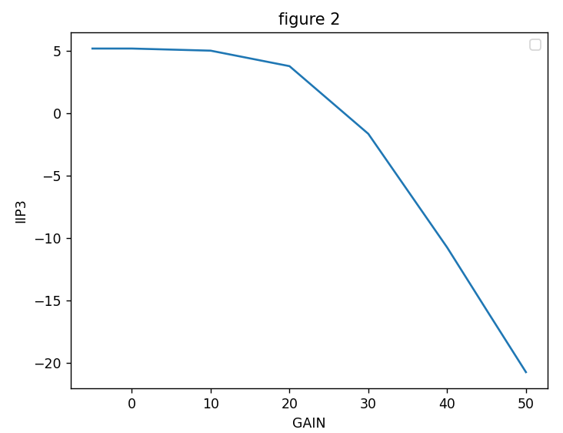

$$\frac{1}{A_{IP3}^{2}}≅\frac{1}{A_{IP3,1}^{2}}+\frac{α_{1}^{2}}{A_{IP3,1}^{2}}+\frac{α_{1}^{2}β_{1}^{2}}{A_{IP3,1}^{2}}+…$$

From the previous equation, ${IIP}_{3}$ will get affected by the gain of the following blocks, and the non-linearity in the following blocks increases as the gain increases.

* **Show the $SNR$, ${IM}_{3}$, & $SNDR$ curves for the receiver versus $P_{in}$**

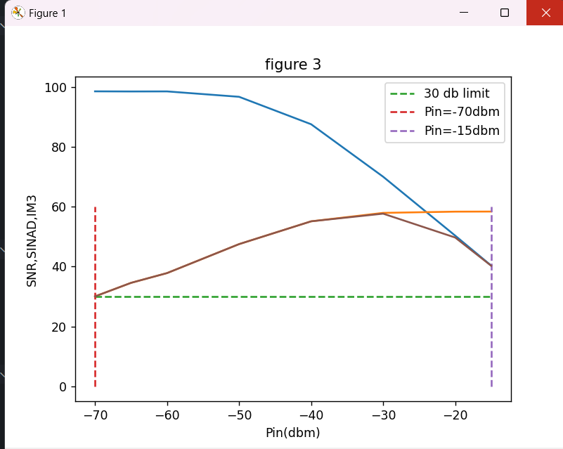

The specs for the $SNDR >30 dB$ is achieved at

🡺 which is shown the values.

$SNDR$ Values:



$P_{in}=-102 dBm$, $Gain=72 dB$, & $NF=2 dB$, required $SNR$ is achieved

$SNR$ value:



* **Plot the gain versus Pin that achieves the above results**

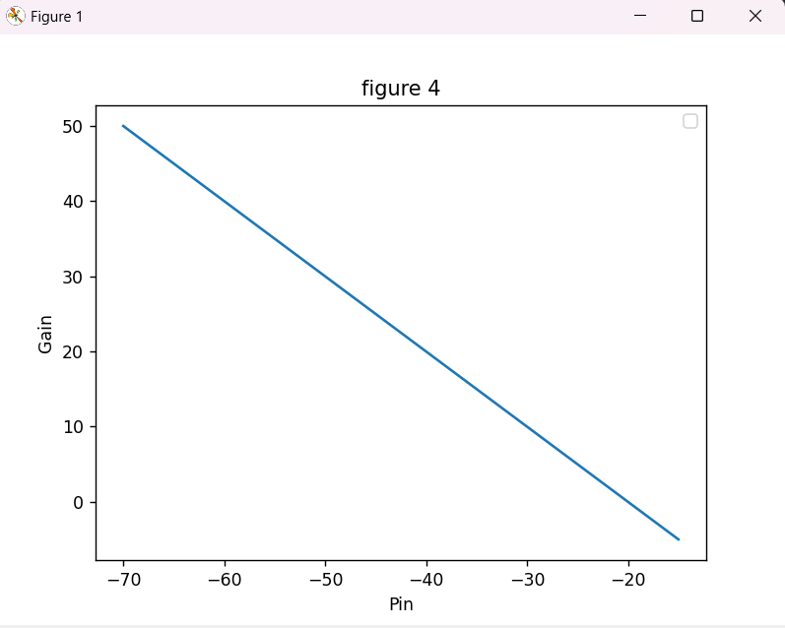

The gain policies used is from $-5 dB→50 dB$ when $P_{in}$ increases by $10 dBm$ the gain decrease $10 dB$ to have a $P_{out}$ in this range of -20 dBm.

**The code used to plot the graphs was done by a python code.**

**The link:**

<https://drive.google.com/file/d/13V8WIza1XixoOcS24BomWlRg7ZyLNQVP/view?usp=sharing>